Ancient Macedonia – Social Structures

***SUMMARISE THE FOLLOWING ON YOUR MIND MAP***

* Evidence we have focusses on the elites and upper classes
* Macedonian elite were called *hetairoi*, or companions.
* The hetairoi met at *symposia*, or big meetings, where they would come together and compete for influence and the king's favour.
* These symposia were notorious for drunken brawls and other debauchery.
* Macedonian women had limited rights. But they were a little better off than women in Greek city-states like Athens, who were almost always secluded at home.
* Macedonians also tended to own fewer slaves than the Greeks.

**Areas of Religious Rituals**

* The Macedonians took religion very seriously and came together at Panhellenic sanctuaries.
* Olympia, Delphi, Nemea, and Argos were some sanctuaries.
* Most of the Macedonian religious festivals were Greek.
* Ancient Dion was a sanctuary for Zeus and was the most important sanctuary of the Ancient Macedonians.
* Vergina was the first capital of Macedon.
* The Capital was moved to Pella in the 5th century BC
* In Pella there was the Council and the Assembly.
* Philippi was the site of a famous battle and one of the first areas to accept Christianity.

## **Philippi**

* The was trade to many Greek Islands such as Crete, Cyprus, and the Cyclades.
* Each area of trade had a specific good to trade.
* The economy depended largely on imported goods so trade was very important
* The Aegean sea was an important area for trade.
* The Macedonians used very similar trade routes as the Greeks.
* There were cities established along the Black Sea.

Ancient Macedonia – Political Structures

***SUMMARISE THE FOLLOWING ON YOUR MIND MAP***

* Unlike Greek city-states that had a kind of democratic government, Macedonia was a **hereditary monarchy:** kingship was handed down to another member of the family.
* Kings often polygamous, meaning they had many wives,
* Succession was sometimes controversial, with various children from various mothers all rivals to be the heir.
* King was the head of state, the commander of the armed forces, and also the head of the religion: the power to mint coins and circulate money.
* Even though the king had ultimate power, he did convene a council called the ***synedrion***. The synedrion was made up of high-ranking Macedonian men, and they would meet to discuss issues and give the king advice. The king didn't get to choose the members of the synedrion because some of them had been guaranteed a spot by birthright.
* The first known Macedonian king is Caranus, and King Amyntas III was the first to really unify all of the regions of Macedonia. The major ruling dynasty of Macedonia was the **Argeads**, who gave us King Philip II and Alexander the Great, who expanded and strengthened Macedonia.
* Basileus (King). Basilikoi paides (royal pages), somatophylakes (bodyguards), hetairoi (companions) or philoi (friends) were all close to the King and could influence him
* There are two positions on the nature of Macedonian kingship. The one (‘constitutional’) holds that the King wasn’t an absolute ruler and that the state was run according to traditions and laws.
* The army had the right to choose King and act as a judge in cases of treason. The second position (‘autocratic’) holds that the King ruled as an autocrat and that other political bodies, such as the army, were consulted on the whim of the King.
* The King was personally involved in directing foreign policy.
* The King owned the natural resources of Macedon such as timber, silver and gold as well as royal land. With those resources, he could finance the military.
* The Macedonian King was first and foremost a warrior.

Ancient Macedonia – Economic Structures

***SUMMARISE THE FOLLOWING ON YOUR MIND MAP***

* Early on, the Macedonian economy relied on its timber resources. Then, they began to acquire some gold and silver mines, and charge port duties.
* There was a big gap between the rich elites and the poor, but as Philip II expanded Macedonian lands, the economy grew.
* Under Philip II and Alexander the economy became **monetary**, which means that coins were issued and used everywhere as money.
* That's a sign of a much more prosperous economy because coins make business transactions go much faster than negotiating and bartering a stack of timber for some sheep.
* The economy was greatly stimulated by the construction of the Via Egnatia, the installation of Roman merchants in the cities, and the founding of Roman colonies.
* The Imperial government brought, along with its roads and administrative system, an economic boom, which benefited both the Roman ruling class and the lower classes. With vast arable and rich pastures, the great ruling families amassed huge fortunes in the society based on slave labor.
* The improvement of the living conditions of the productive classes brought about an increase in the **number** of artisans and craftspeople to the region.
* Stone-masons, miners, blacksmiths, etc. were employed in every kind of commercial activity and craft. Greek people were also widely employed as tutors, educators and doctors throughout the Roman world.
* The export economy was based essentially on agriculture and livestock, while iron, copper, and gold along with such products as timber, resin, pitch, hemp, flax and fish were also exported.
* Another source of wealth was the country's ports, such as Dion, Pella, Thessalonika, Kassandreia, and Neapolis.

Ancient Macedonia – Religious Structures

***SUMMARISE THE FOLLOWING ON YOUR MIND MAP***

* Same Gods as Greeks: worshipped the 12 Olympians
* Zeus was the single most important deity
* Makedon, the mythical ancestor of the Macedonians, was held to be a son of Zeus, and Zeus features prominently in Macedonian coinage.
* The most important centre of worship of Zeus was at Dion in Pieria, the spiritual centre of the Macedonians, where beginning in 400 BC King Archelaus established an annual festival, which in honour of Zeus featured lavish sacrifices and athletic contests
* Worship of Zeus's son Heracles was also prominent; coins featuring Heracles appear from the 5th century BC onwards.
* This was in large part because the Argead kings of Macedon traced their lineage to Heracles, making sacrifices to him in the Macedonian capitals of Vergina and Pella.
* Importance of the worship of Artemis. Artemis was often depicted as a huntress and served as a tutelary goddess for young girls entering the coming-of-age process, much as Heracles Kynagidas (Hunter) did for young men who had completed it.
* Macedonian elite built lavish tombs at the time of death rather than constructing temples during life
* Macedonian burials contain items similar to those at Mycenae, such as burial with weapons, gold death masks
* Macedonian monarchs seen as Gods: began with the death of Philip II, yet it was his son Alexander the Great who unambiguously claimed to be a living god
* Alexander visits the oracle of Didyma in 334 BC to confirm his divine status: priest there convinced him that Philip II was merely his mortal father and Zeus his actual father, Alexander began styling himself as the 'Son of Zeus’,

Ancient Macedonia – Military Structures

***SUMMARISE THE FOLLOWING ON YOUR MIND MAP***

* One of Philip's most important achievements: reforming the Macedonian army - Introduced lighter weaponry and an extra long pike or spear called a sarissa.
* Philip took the soldiers on forced marches carrying their gear to get them in battle shape
* Improved some tactics he learned in Greece like the phalanx, in which soldiers marched together in a tight formation like a finger.
* He improved siege warfare with better catapults and used cavalry forces together with ground troops in a revolutionary way.
* King Philip II had grand visions of taking over all of Greece and parts of Asia, but he knew that he would have to be clever and patient.
* He used all sorts of diplomatic strategies, and even bribes, to placate and conquer Greek city-states.
* He was brilliant at playing city-states against one another, inflaming their rivalries so that they would not unite against him. When the time was right, he would strike with his elite military.

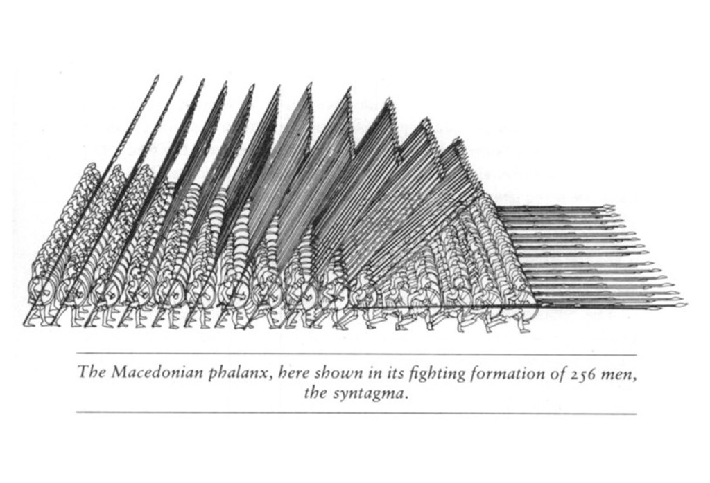

Ancient Macedonia – Cultural Structures

***SUMMARISE THE FOLLOWING ON YOUR MIND MAP***

* Macedonian elite: importing significantly greater customs, artwork, and art traditions from other regions of Greece.
* Macedonian metalwork usually followed Athenian styles of vase shapes from the 6th century BC onward, with drinking vessels, jewellery, containers, crowns, and coins among the many metal objects found in Macedonian tombs.
* Surviving Macedonian painted artwork includes frescoes and murals on walls, but also decoration on sculpted artwork (such as statues)
* Mosaics serve as another significant form of surviving Macedonian artwork, especially those discovered at Pella dating to the 4th century BC: with mythological themes
* Common themes of Macedonian paintings and mosaics include warfare, hunting and aggressive masculine sexuality (i.e. abduction of women for rape or marriage)

Ancient Macedonia was a culture rich in artistic achievements and scientific advances. Aristotle, considered by some the father of western philosophy, may have composed some of his most important works during the reign of Alexander the Great, including treatises on physics and metaphysics (a branch of philosophy dealing with the nature of reality).

The period after Alexander’s death, known as the Hellenistic Period, was one of extravagance and wealth throughout much of the Greek world. Places of entertainment and leisure, such as parks and theaters, proliferated.

A style of Greek drama called New Comedy became popular. Unlike earlier Greek comedies, which parodied public figures and events, New Comedy focused on the fictional trials of average citizens.

Alexandria, an ancient Egyptian town thought to be founded by Alexander the Great, became a major hub of science during this period as well. Greek mathematician Euclid, who taught in Alexandria, founded the study of geometry with his mathematical treatise The Elements.

In one of the tombs at Aigai, the so-called tomb of Persephone, archaeologists uncovered a wall painting showing Hades’ abduction of Persephone to the underworld. It’s one of few existing depictions of mystic views of the afterlife from this period of Greek history.